Nama : Dwi Febi Fauzi

NIM : 18090125

Kelas : 5C

1. URL : http://localhost/ci_fauzi/index.php/MatakuliahValidation
2. Source Code

* application 🡪 config 🡪 database.php

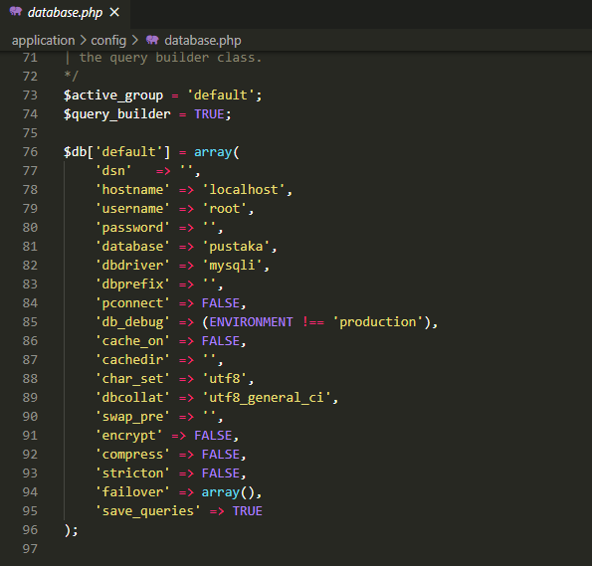

* application 🡪 controller 🡪Bootstrap.php

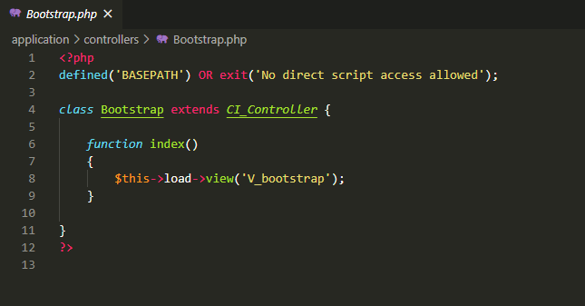

* application 🡪 view 🡪V_bootstrap.php

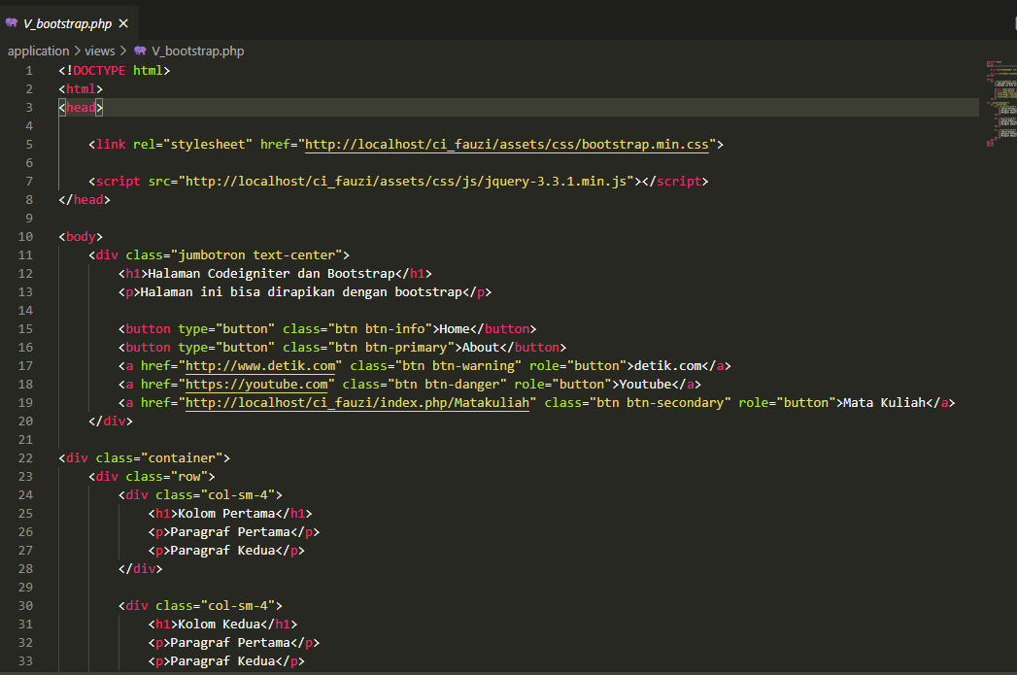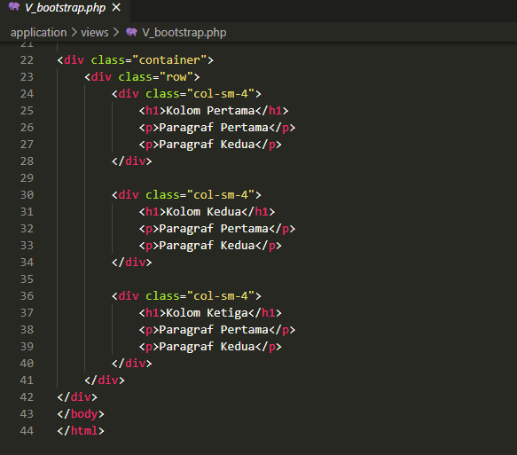

1. Screen Shoot

